**Online Shopping**

**Introduction**

Online shopping user login, admin login and admin operations are implemented in this project.

This project uses four database tables as mentioned below and functionality is also explained in depth in this document.

**Assumptions**

* As this project implements login part, it does not require any assumptions before admin or user login.
* After User login, shopping screens are not implemented and assumed that they will be implemented by other developers.

**Data Dictionary**

Three tables used in this project are

1. User Details

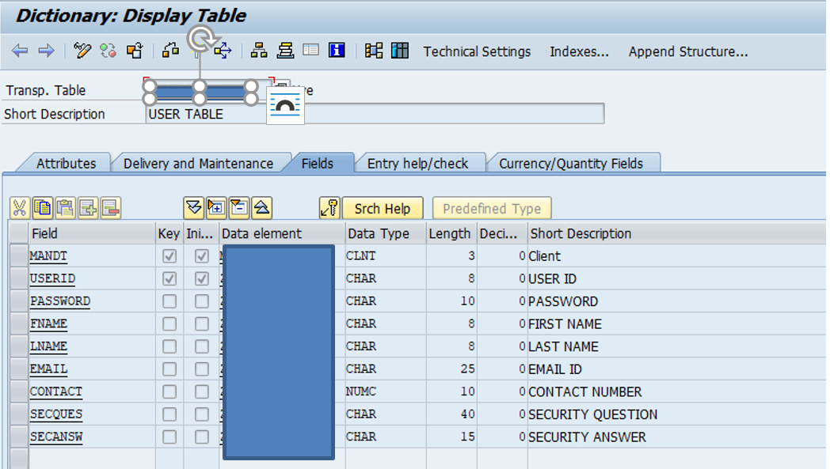

1. Admin Details

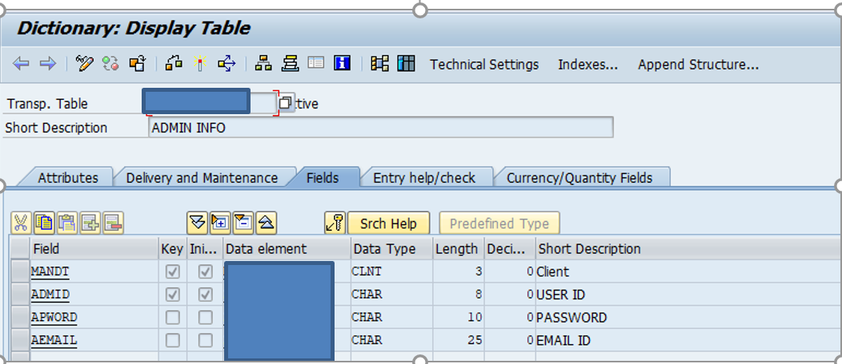

1. Inventory Details

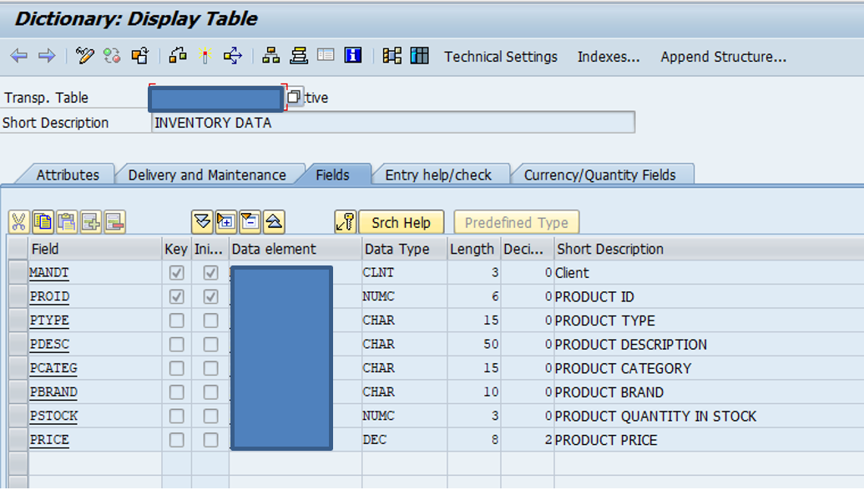

**Functionality**

When you run the program, screen shown below will appear as home screen.

**Home Screen :**

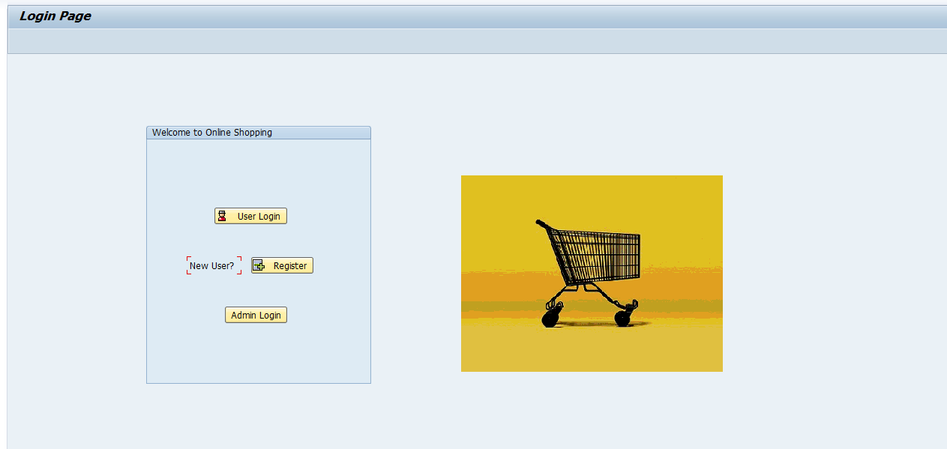

There are three options on home screen user login, user registration and admin login.

As a new user, when you select registration option, user registration screen will appear as shown below.

**User Registration Screen :**

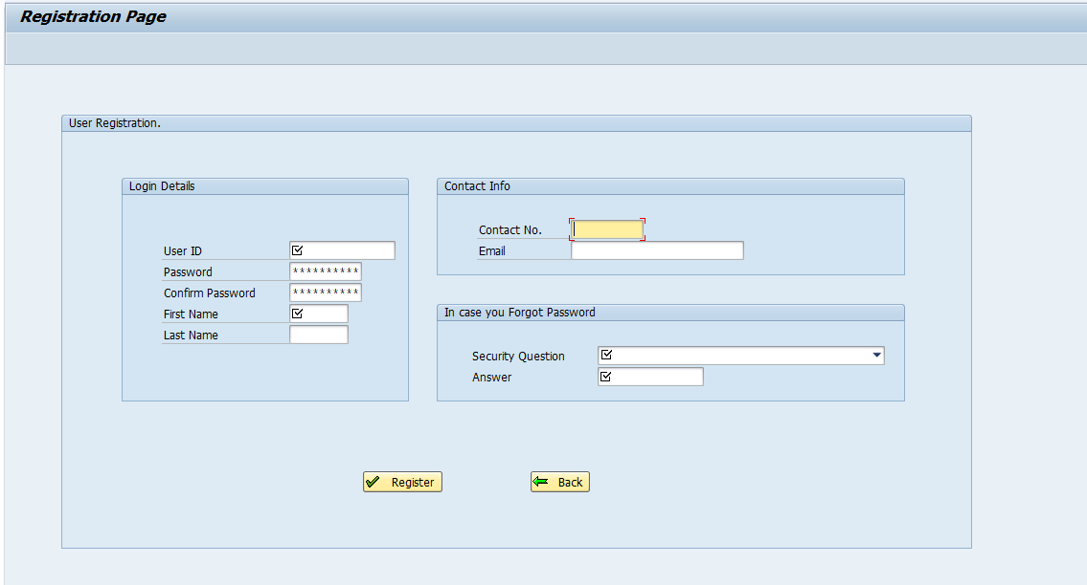

After filling all details, data will be inserted in user details table and you will be redirected to user login screen as shown below.

**User Login Screen :**

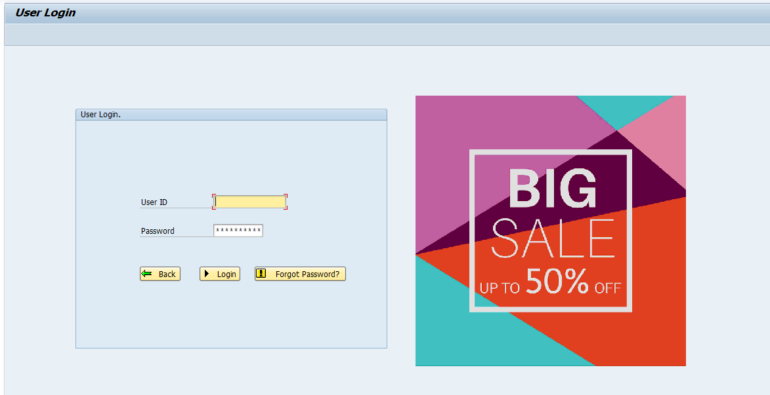

After filling right details and pressing login button, user will be directed to user shopping screen.

**User Shopping Screen :**

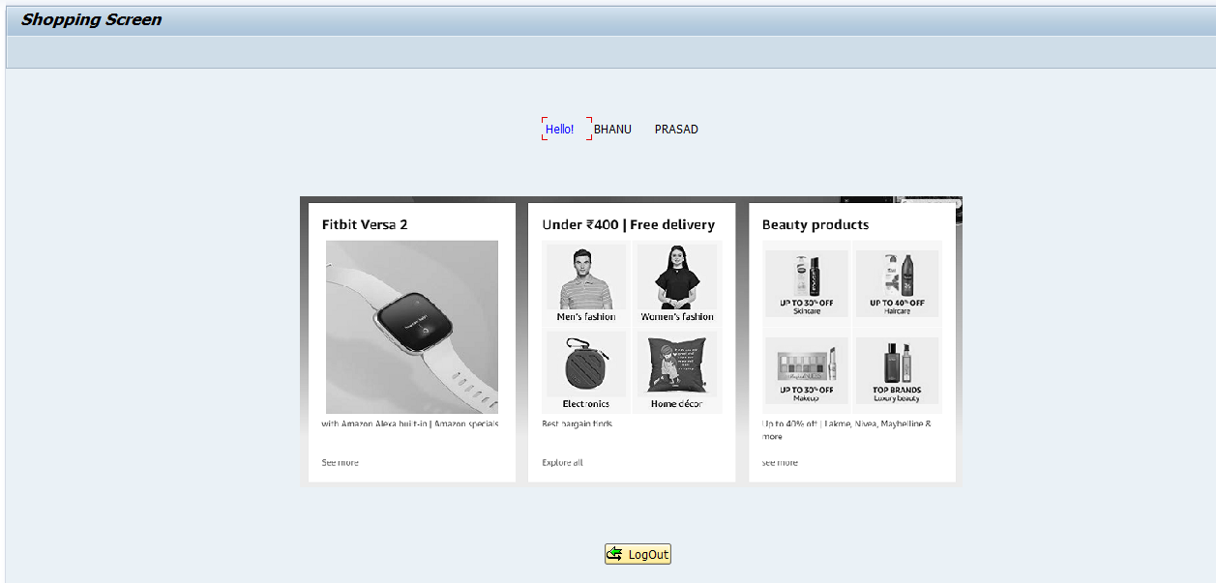

This screen only have one button to logout as other functionalities are not implemented under this project.

**Logout Popup :**

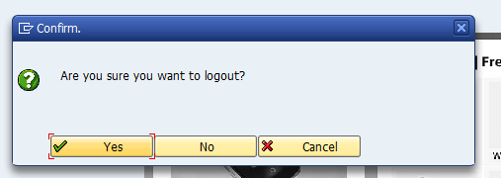

When user press logout button, popup will appear asking for surety to logout.

**Forgot Password :**

If user selects forgot password below screen will appear asking for security question and answer mentioned during registration. Question will appear automatically after entering userid.

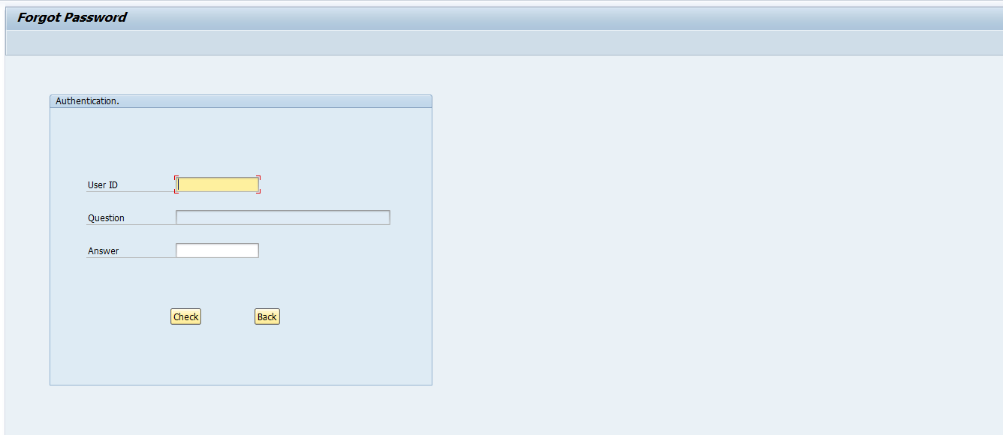

After pressing check button, if the credentials are right, ‘authentication’ window will disappear and ‘set new password’ window will appear.

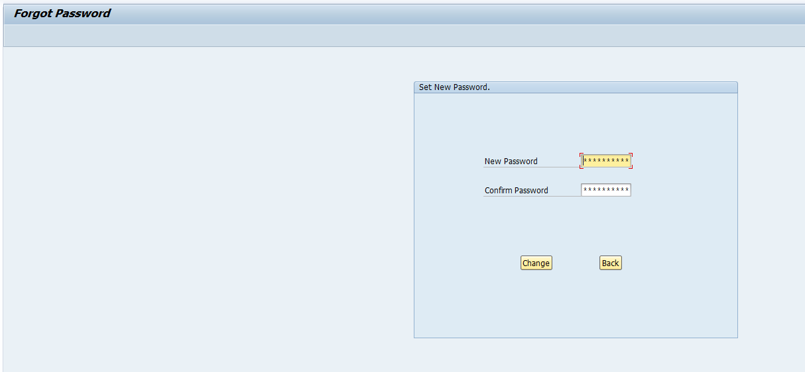

After entering new password, if both password matches, user will be redirected to user login screen.

**Admin Login Screen :**

After selecting admin login button on home screen, admin will be redirected to admin login screen shown below.

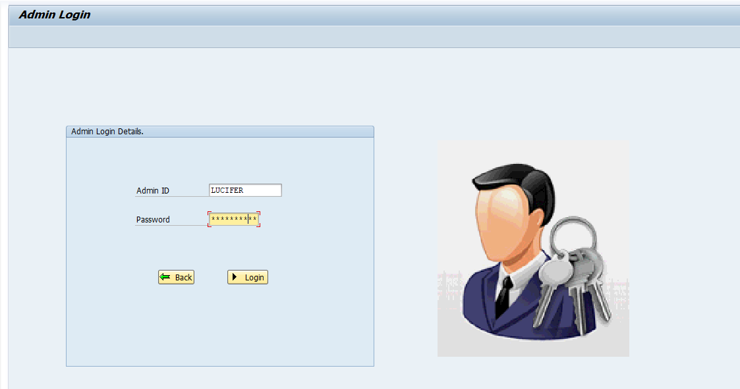

After entering right details, admin will be redirected to below screen.

**Product Selection and Modification Screen :**

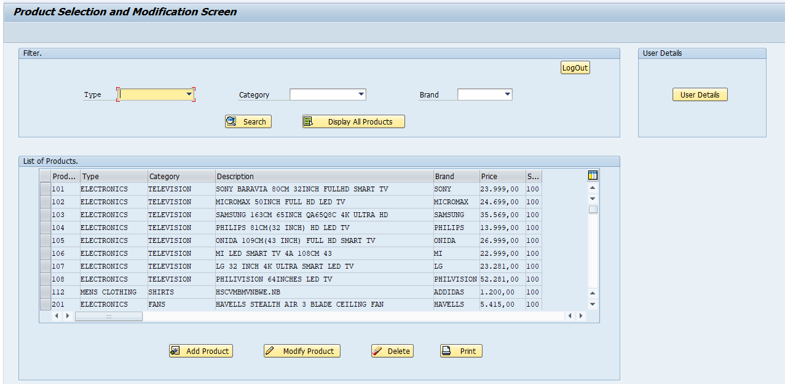

On this screen admin can filter product, add product, modify product, delete product and see user details.

**Modify Products :**

After selecting product and pressing modify button, model dialog box will appear with all the details of product, admin can modify them and press save product push button, data will be modified in inventory database table.

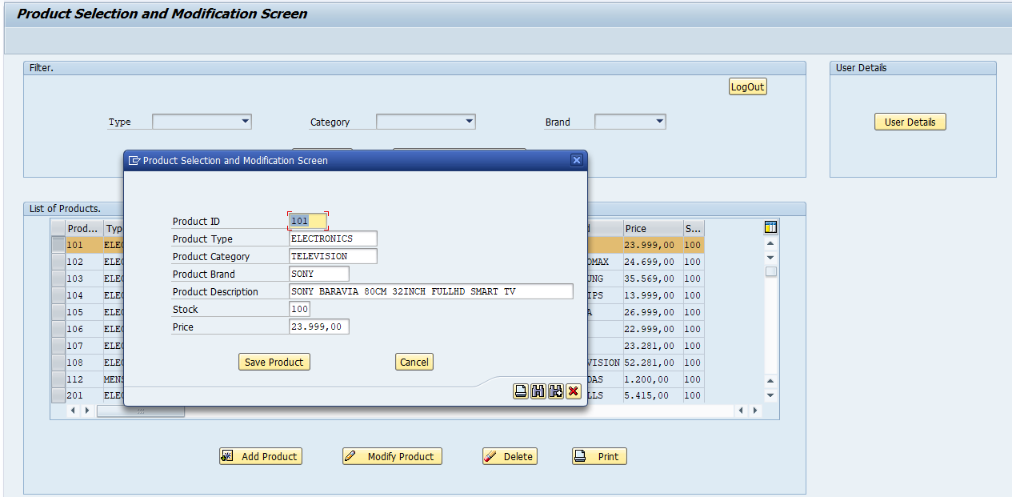

**Add Product :**

After pressing add product push button, model dialog box will appear with all fields blank, admin will enter the data and press save button, product will be added in inventory database table.

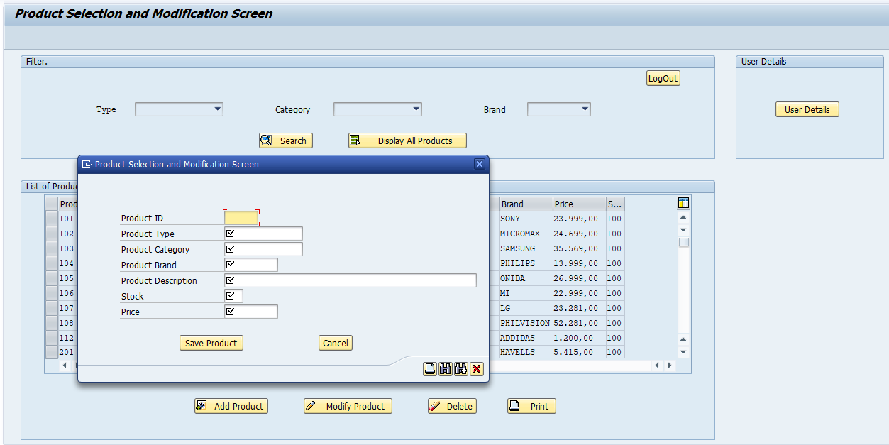

**User Details ALV :**

If admin wishes to see user details, he/she will press user details push button and user details will be shown in ALV.

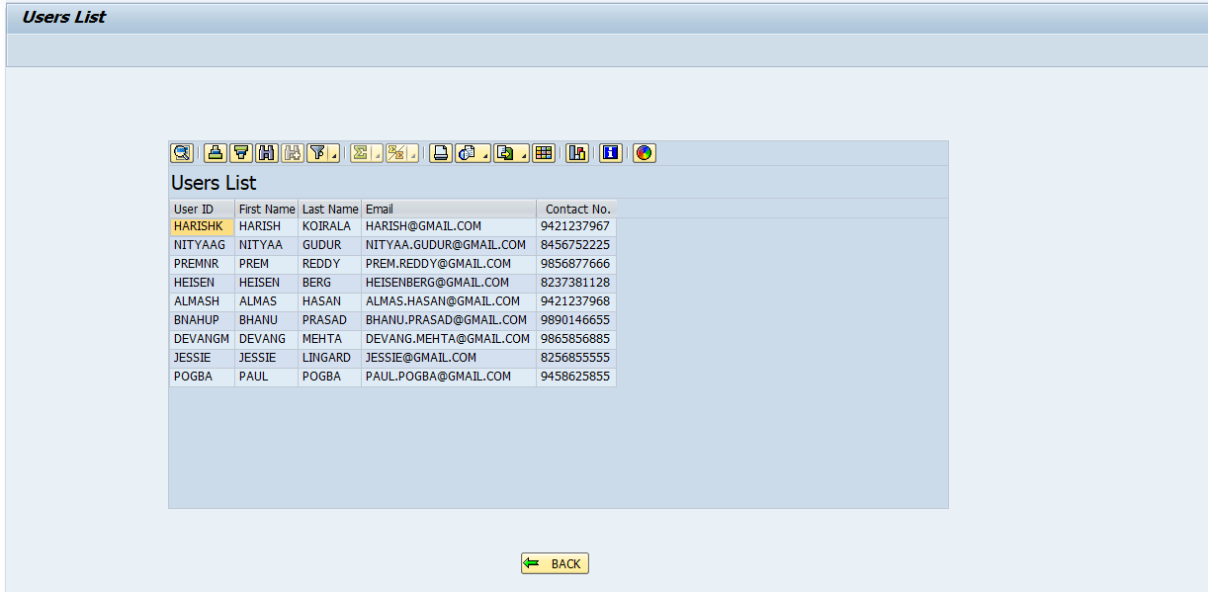

**Product Details Print ALV :**

If admin needs to print the product data in table control, he/she will press print button and all products in table control will be displayed in form of ALV.

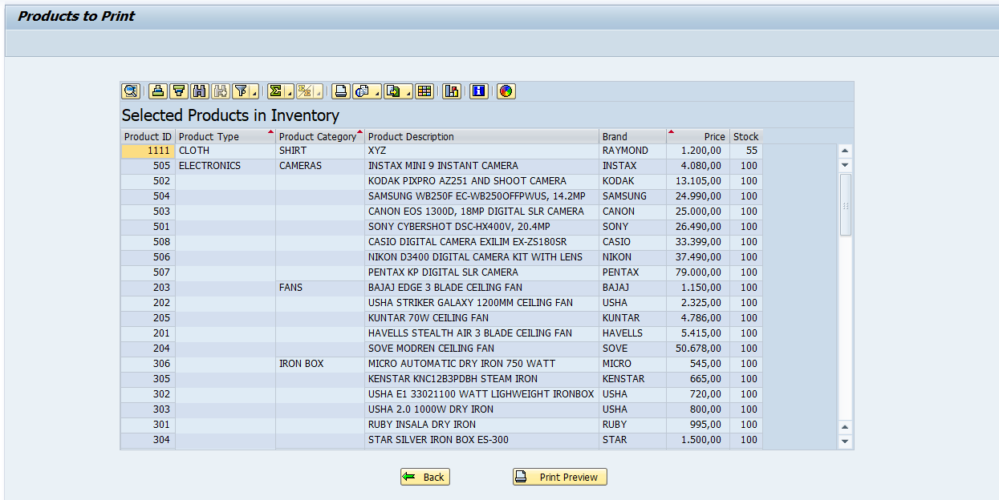

**Print Preview :**

To check the print preview, admin will press print preview push button, adobe form will be generated as shown below.

First page-

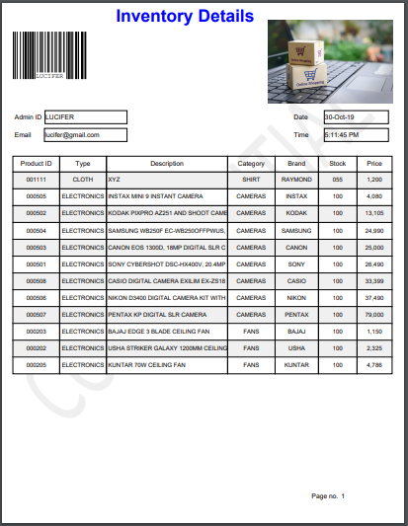

Last Page-

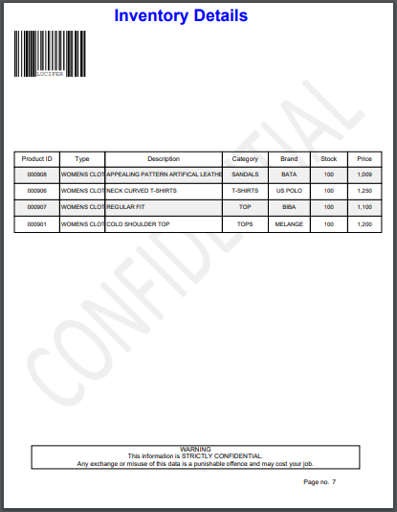

**Conclusion**

This project implemented small functionality of online shopping, user and admin login and also some admin operations.

Login and logout part is made secured and user cannot access database. Only admin can perform DML operations on database such as add product, modify product and delete product.